MYSQL COMPLETE PRACTICLE
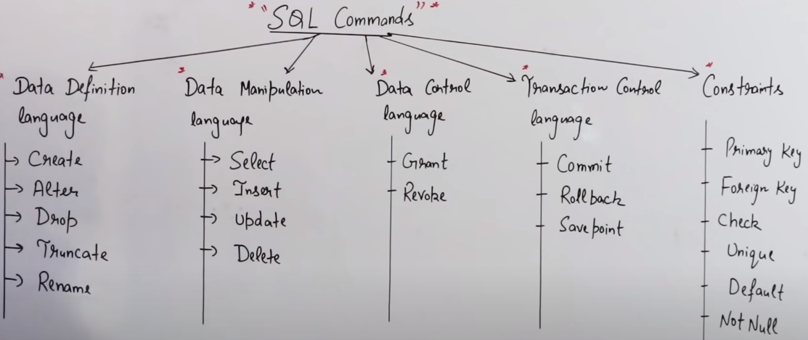
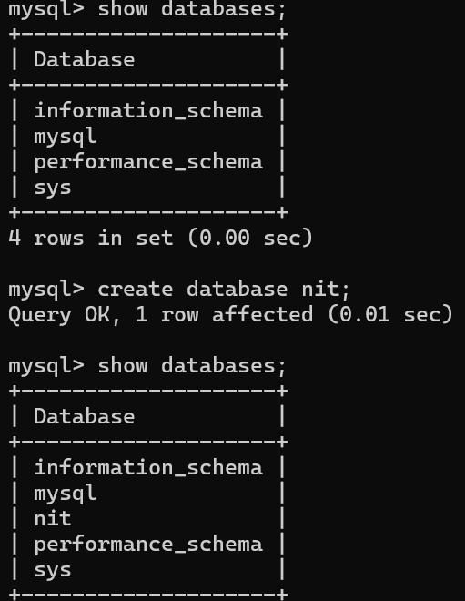
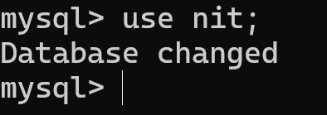
create nit db – use nit db –
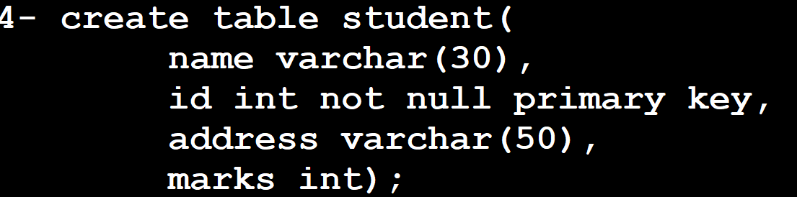
create student table with column ( name, id is not null and also ID will be the primary key, address, marks) – for describe the table use desc
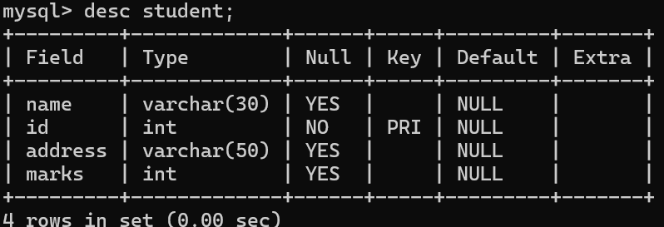
Once table created then we need insert the value to the table 2 way – secure way & insecure way
1st query is secure way & 2nd query is insecure way (INSERT QUERY)
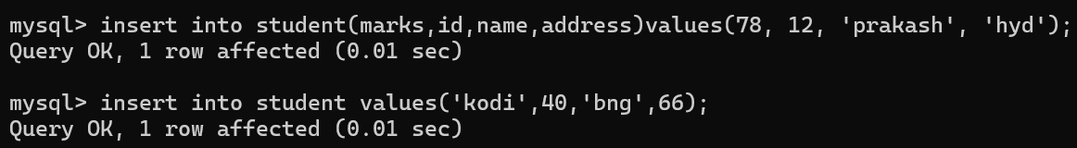
User can also insert multiple value in direct way
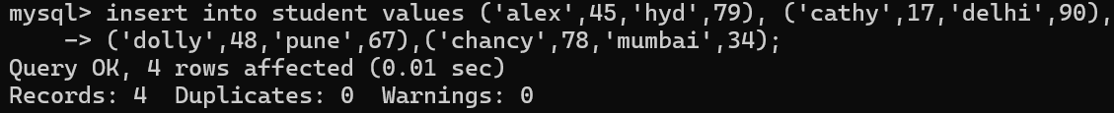
Data stored inside the table & you wanted to see the table then we will use (SELECT QUERY)
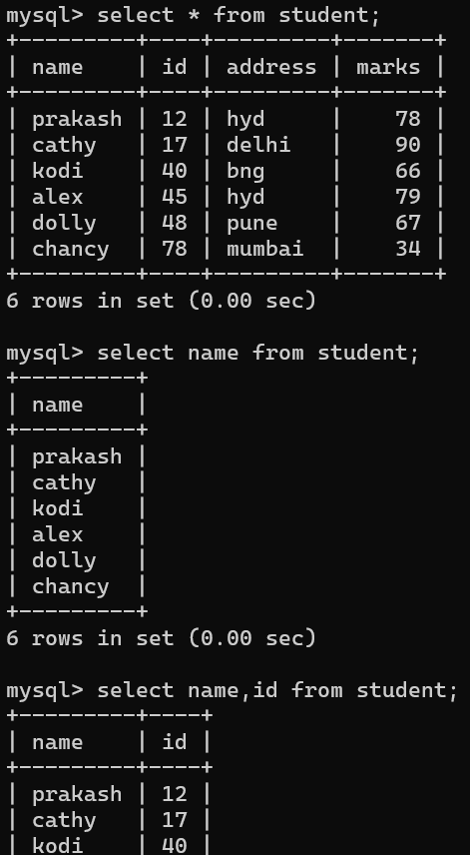
User need to see the record WHEREid =12 & 3 type of select statement
Select the entire table || select the column || select the raw by condition or WHERE clause
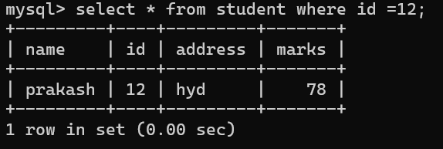
Once you make ID as primary key you can’t insert any value & it will be always unique. ID column never duplicate because we make id as primary key
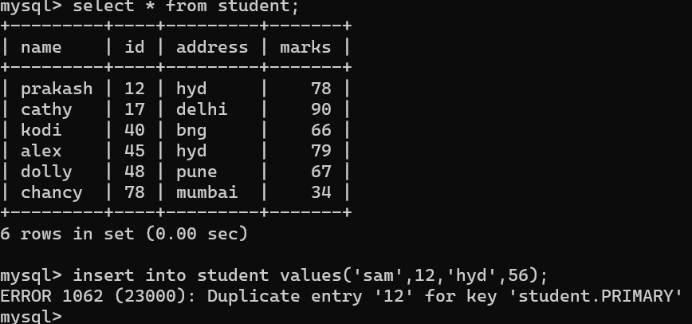
User want to update wherever you find address as Mumbai want to modify Chennai then (UPDATE)
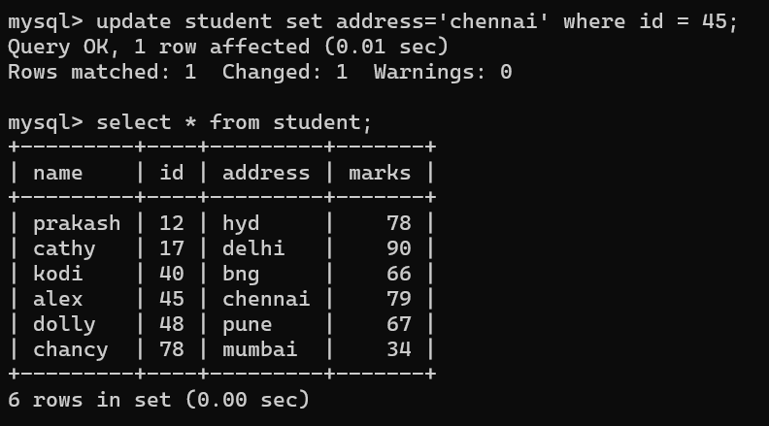
If user want to add any column in existing table (ALTER)but everything is added with null
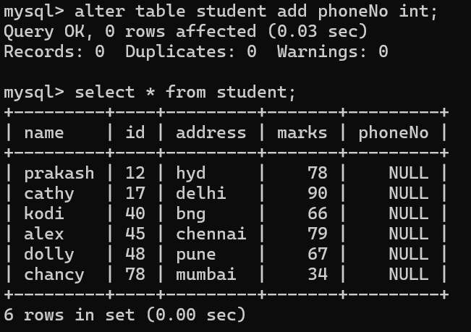
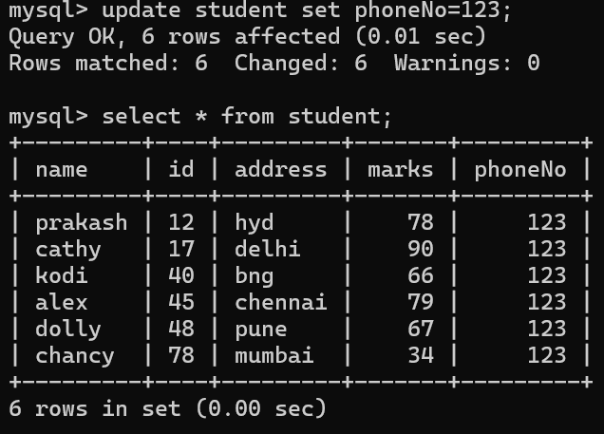
User want to change specific phoneNo then you need to write the condition
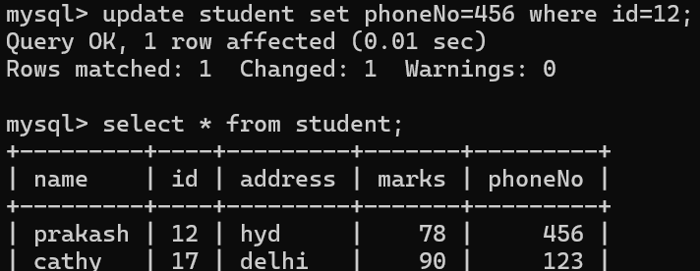
Want to change the column type –
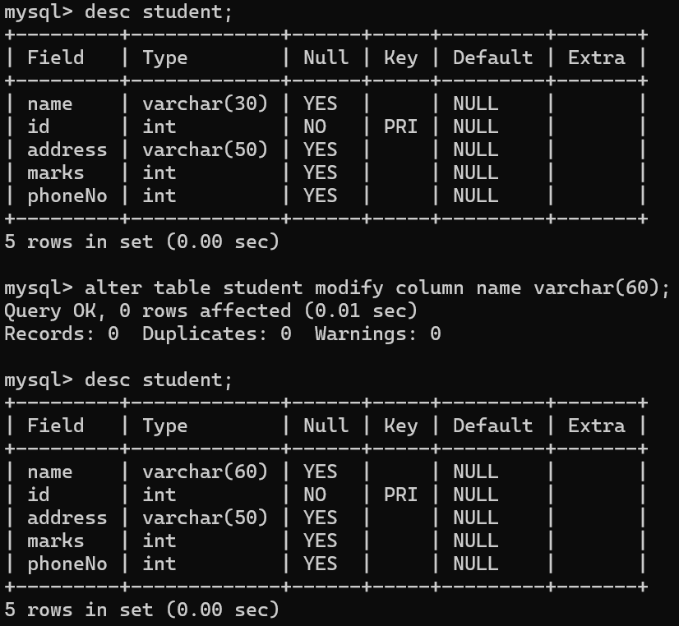
User can drop the column name from the table as well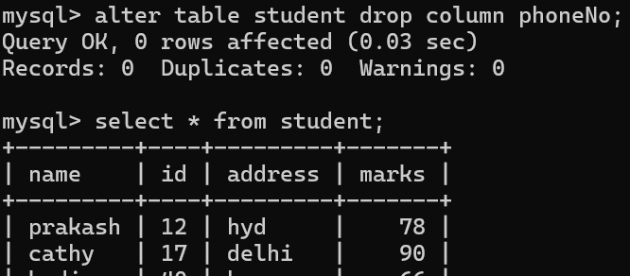
DELATE ANY DATA – DML command&Changes any structure – DDL COMMAND
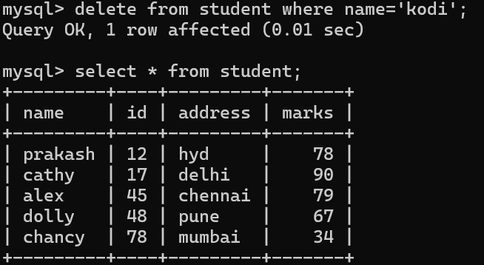
Lets introduce to sql functions
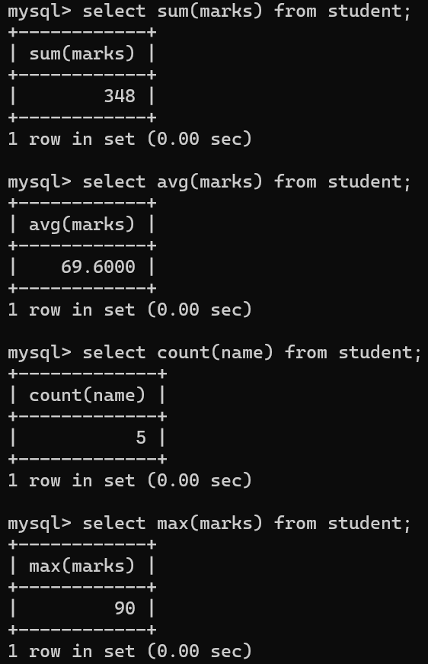
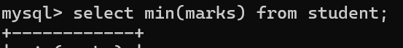
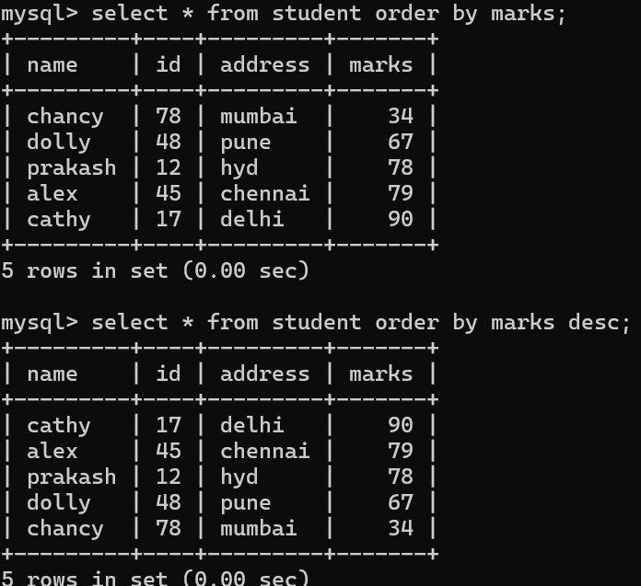
Wild card character
Student name which start with a then you need to use wild card character
Pull out the records of student name which start with a (‘a%’) & names which end with y then’%y)
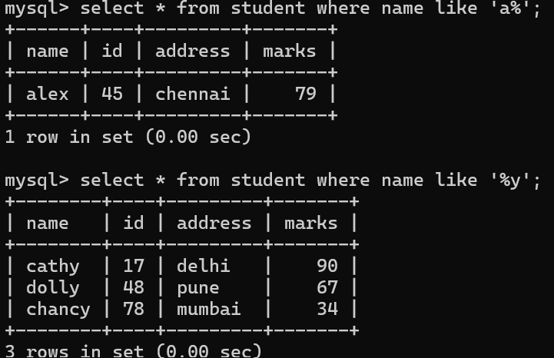
Pull out the records where second alphabet is ‘a’ then use 2nd wildcard
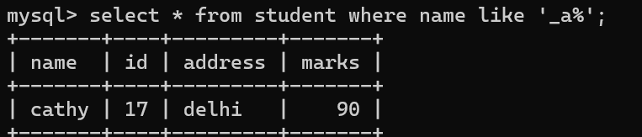
Pull out the records where second last alphabet is ‘s’ then use below query
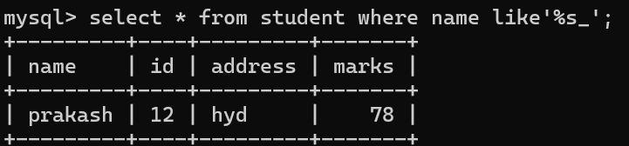
Lets create another table to make joins –
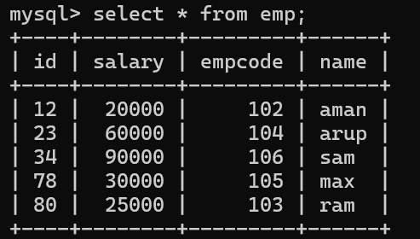
Now user has 2 table under nit database || Innerjoin– it will display the common records
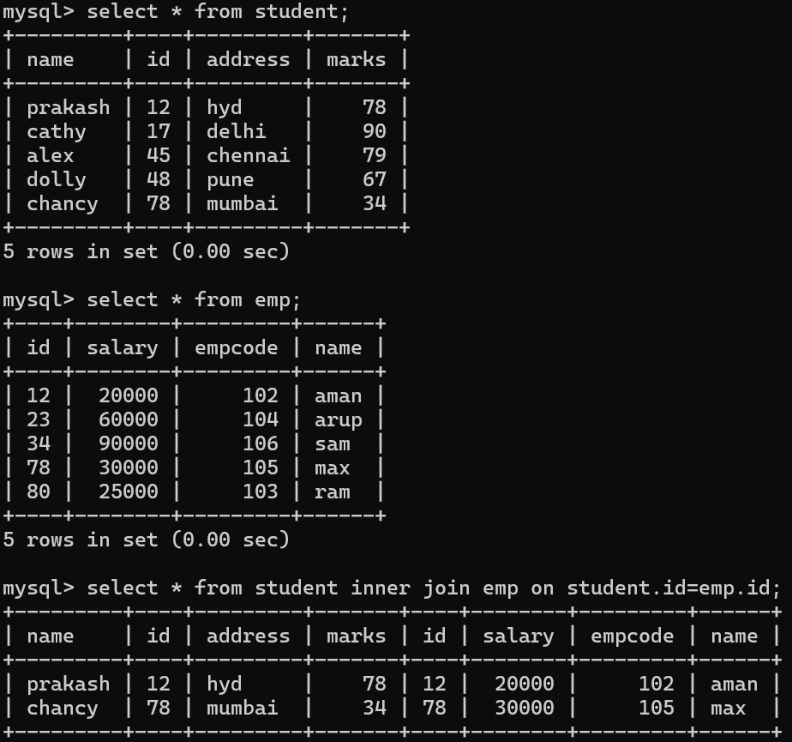
LEFT JOIN (LEFT OUTER JOIN)
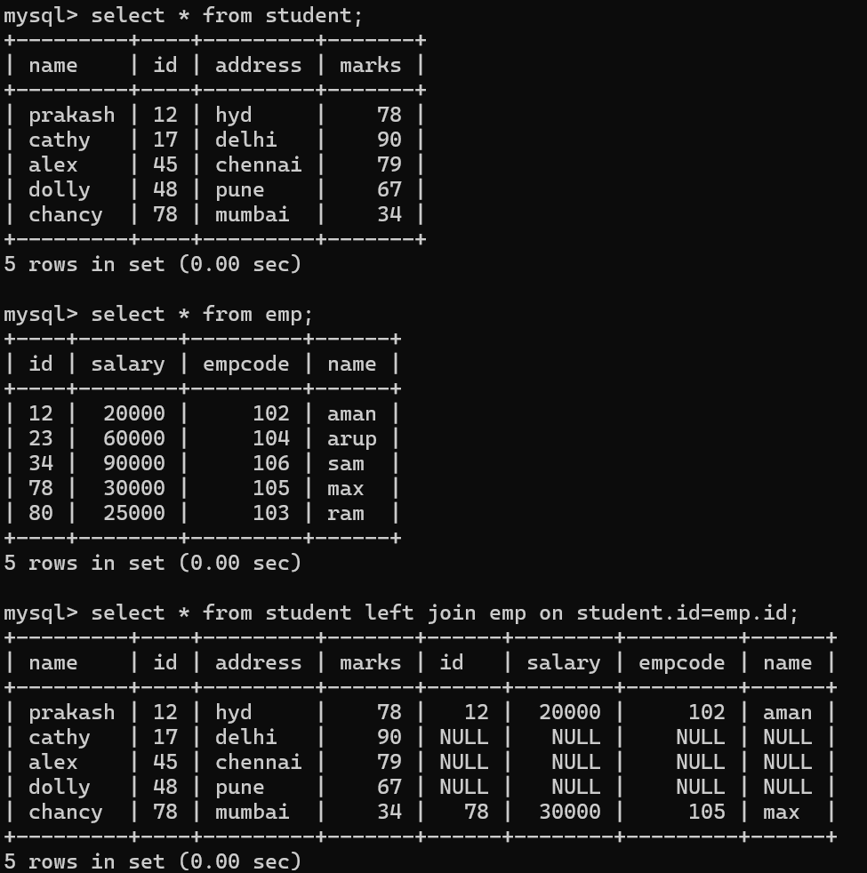

RIGHT JOIN (RIGHT OUTER JOIN)
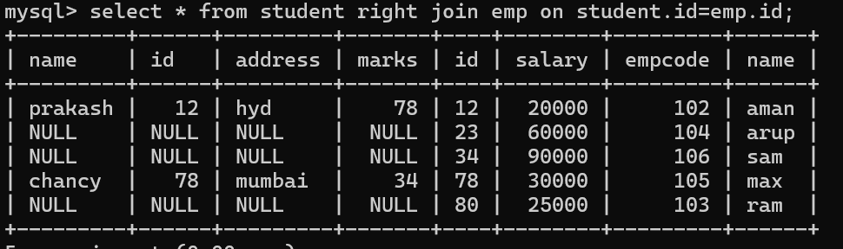
CROSS JOIN
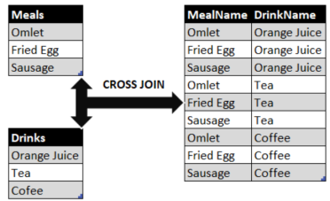
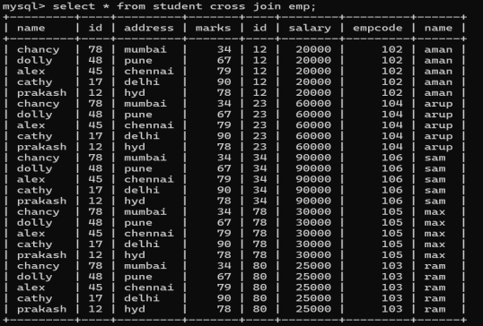
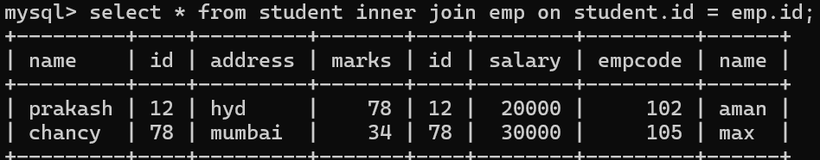
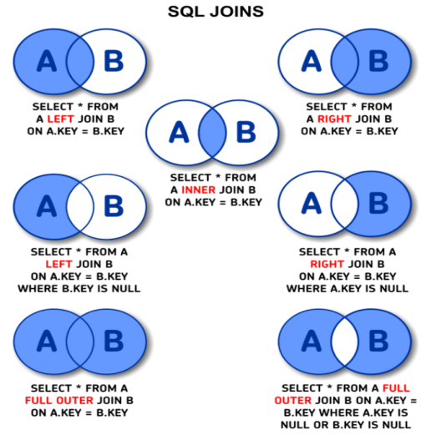
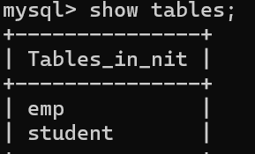

SQL TRANSACTION(COMMIT, ROLLBACK, SAVEPOINT)
Always use START query for sql transaction
Create another student1 table & use below query for this.
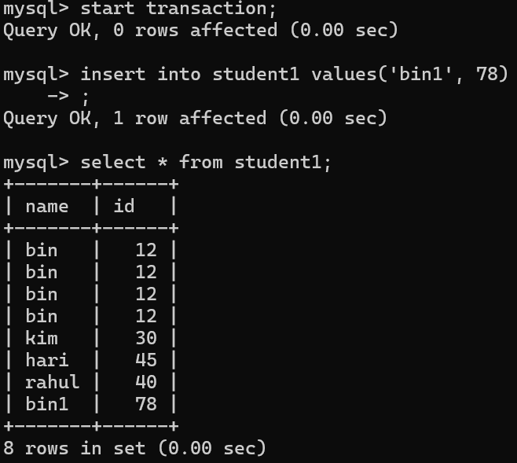
Below query user delathari
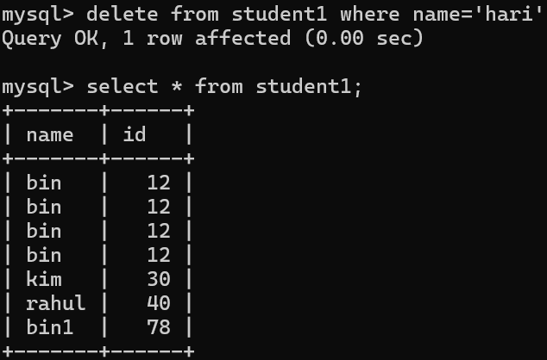
Due to some mistake you enter wrong query and delated the records that’s why we will do ROLLBACK. If you delated any records from table once use rollback it will give original table.
ROLLBACK will act link undo (ctrl+z)
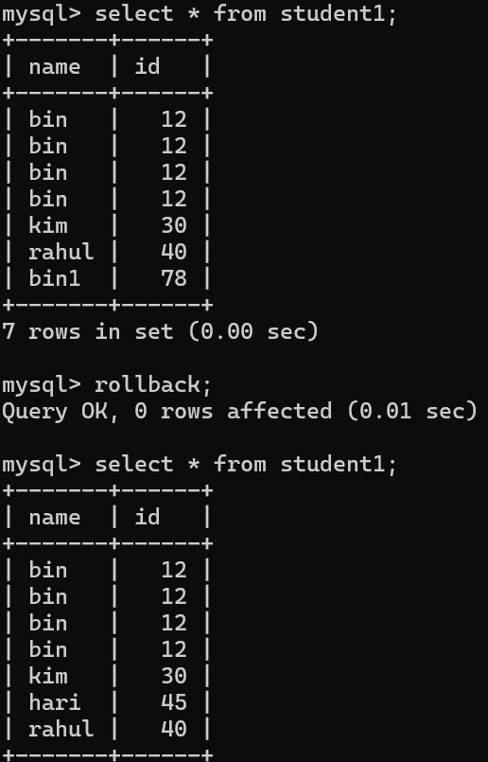
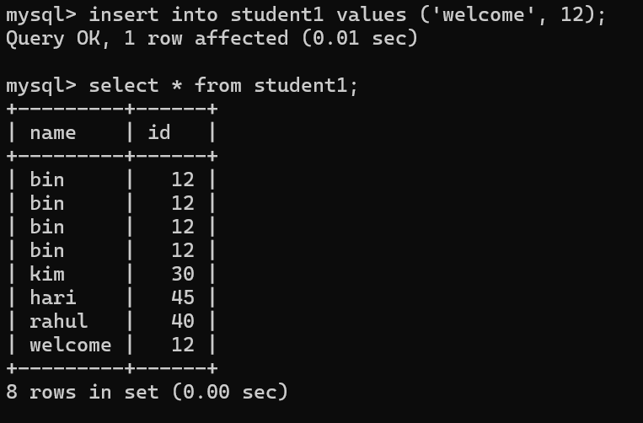
Once user define COMMIT & then ROLLBACK will never work
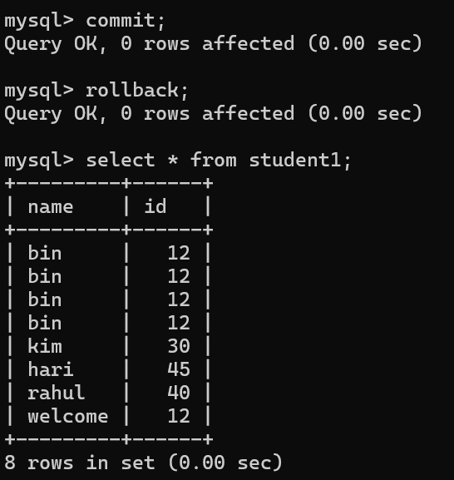
Lets run below query without commit and records are removed but ROLLBACK is not working
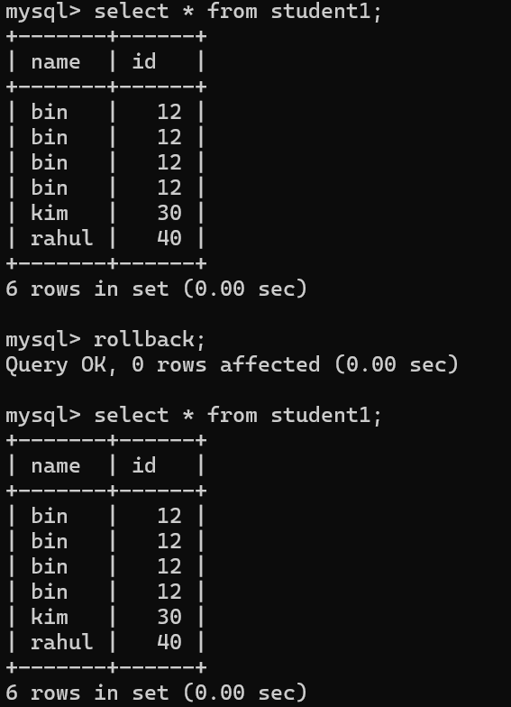
ROLLBACK IS NOT WORKING WHY . THAT’S WHY WE NEED TO WRITE 1ST IS start TRANSACTION
Once user mention START TRANSACTION THEN ROLLBACK WILL WORK
When user mention ROLLBACK will work.

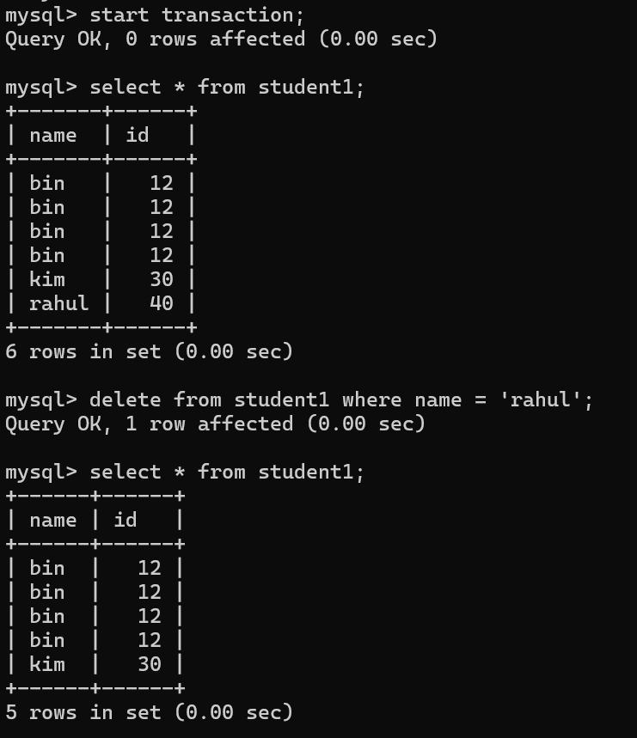
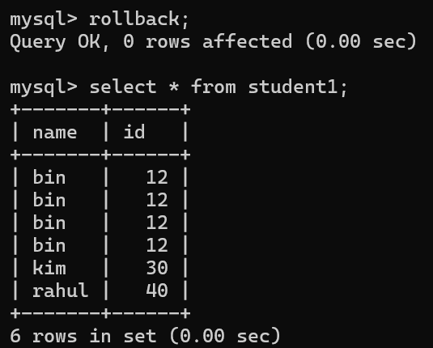
Let’s introduce to savepoint for that again we will start the transaction
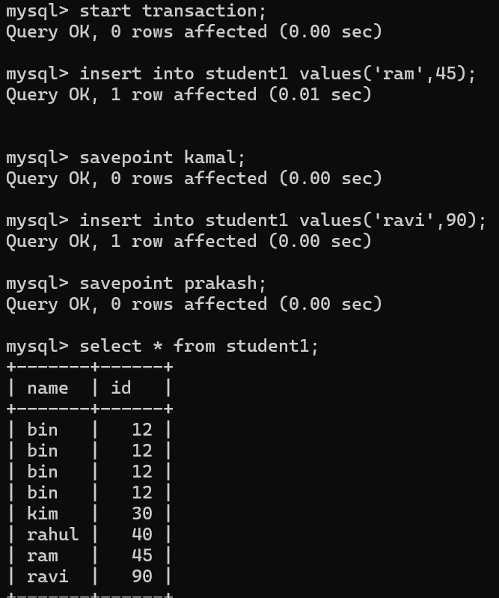
Above query start the transaction and insert value ram and then savepoint to kamal.
After savepointkamal then add ravi value & save point to prakash. Once you roll back to kamal then you cannot able to see the ravi value
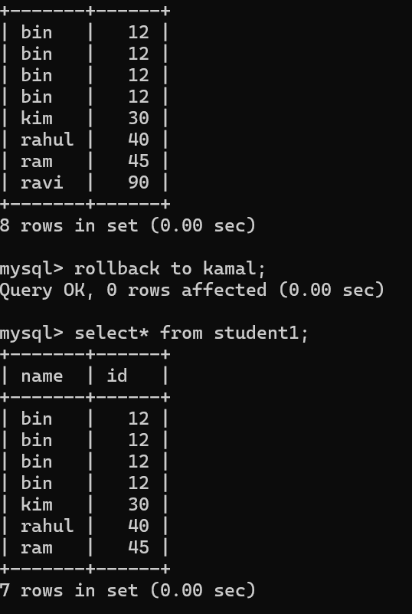
Lets take another example of rollback &savepoint
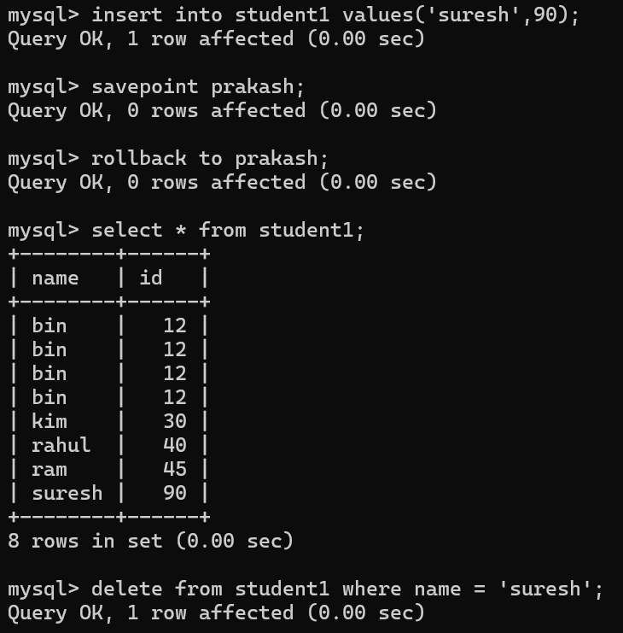
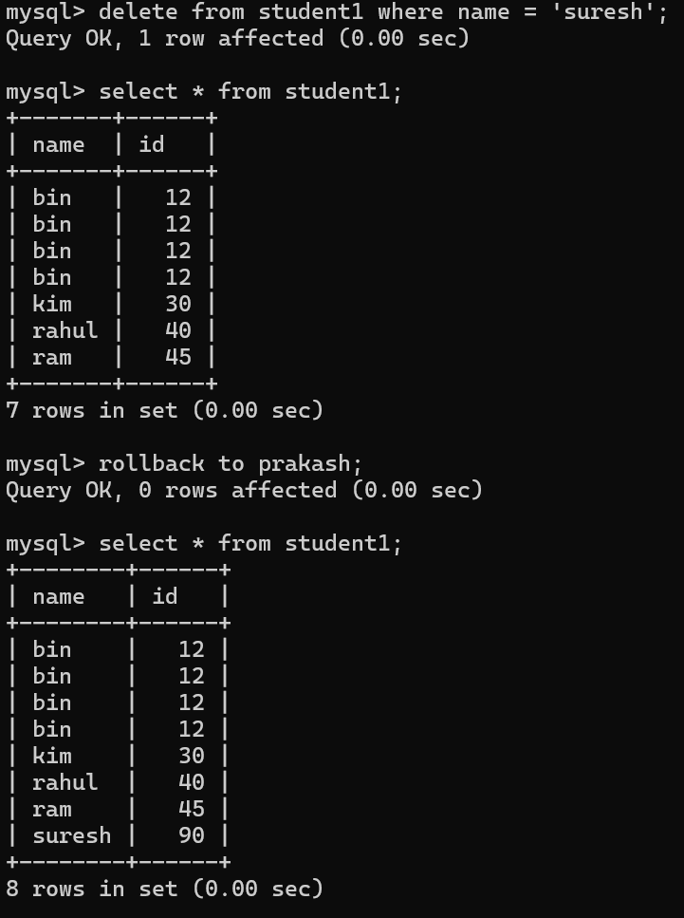

LETS UNDERSTAND DDL COMMAND
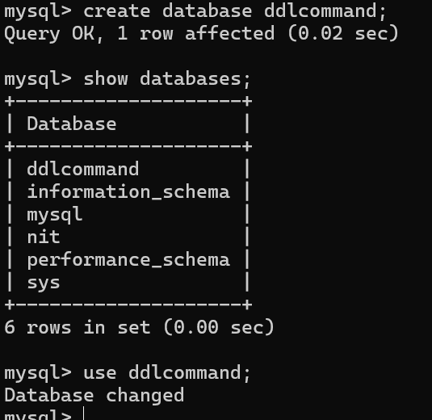
Create command will create the table
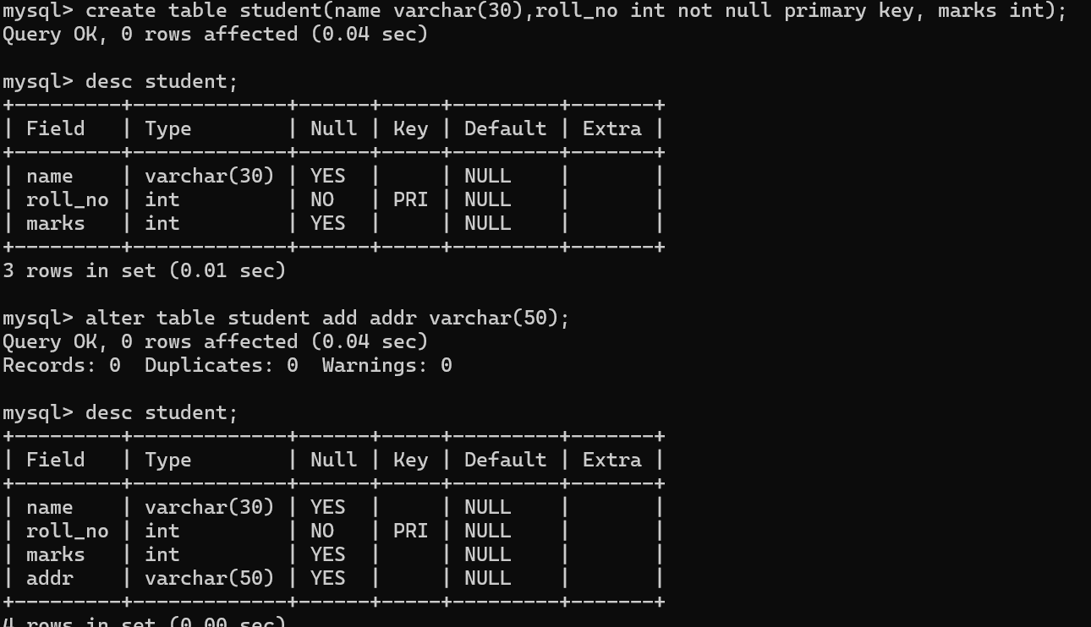
Alter command will modify the data, delate the data
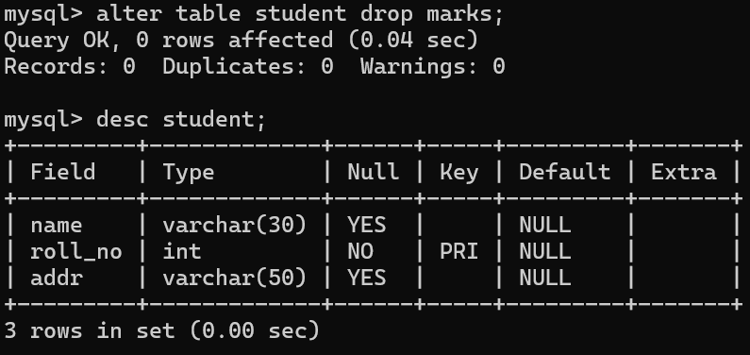
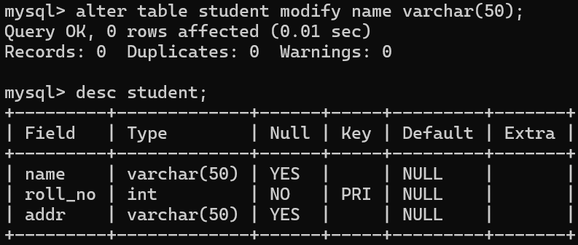
Using alter command user can change the primary key as well.
Refer to below query.
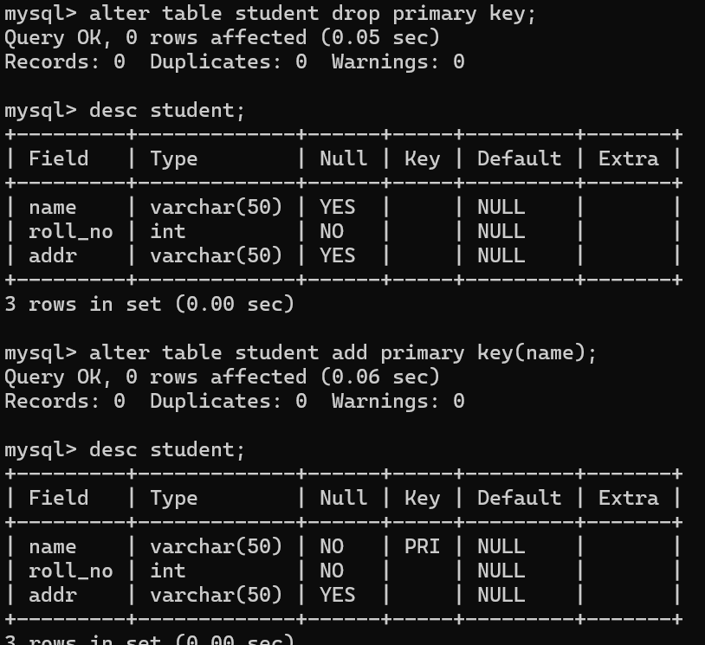
Alter command also help to rename the table name
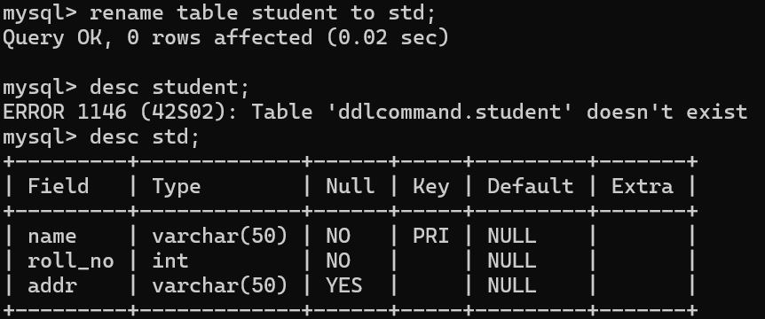
TRUNCATE command will act like clear the value from table but table will be display
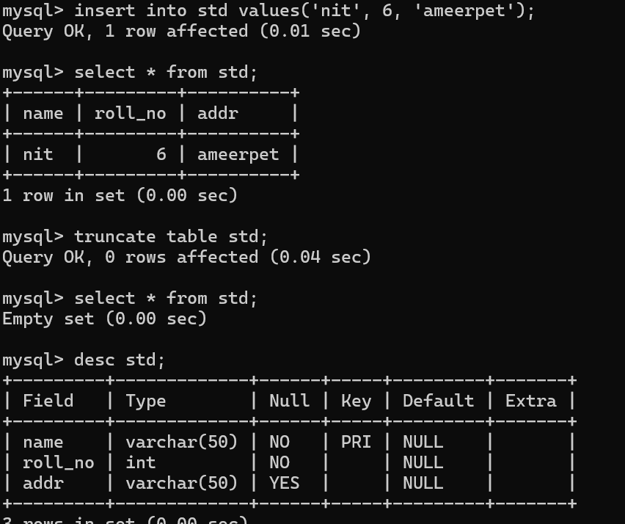
DROP command will delate the entire table with value
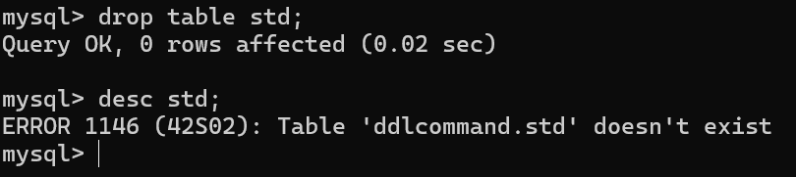
PRIMARY KEY
Primary keys serve as unique identifiers for each row in a database table. Foreign keys link data in one table to the data in another table.
This is 1way to create as primary key
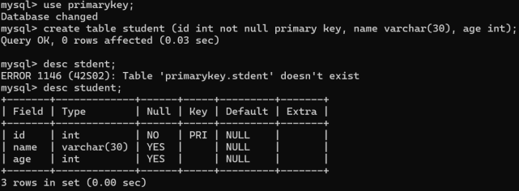
2nd way to create primary key as
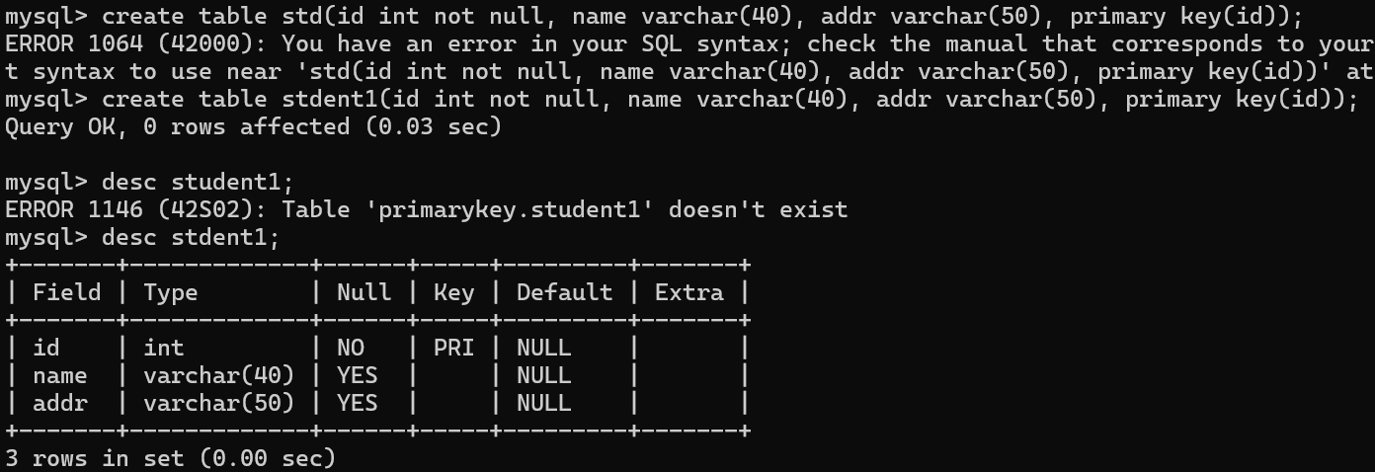
How to create primary key to multiple column let see below query
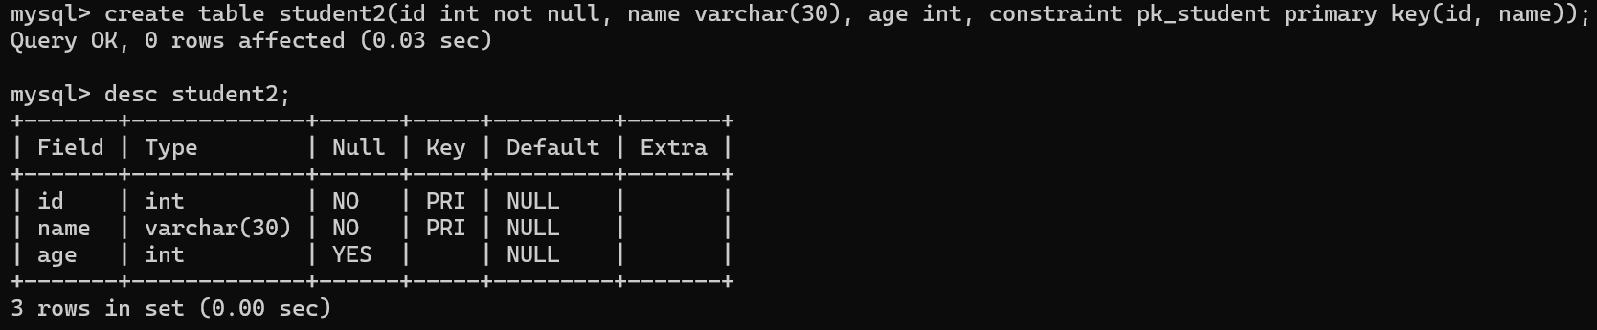
User already created table but forget to assign primary key then use alter command
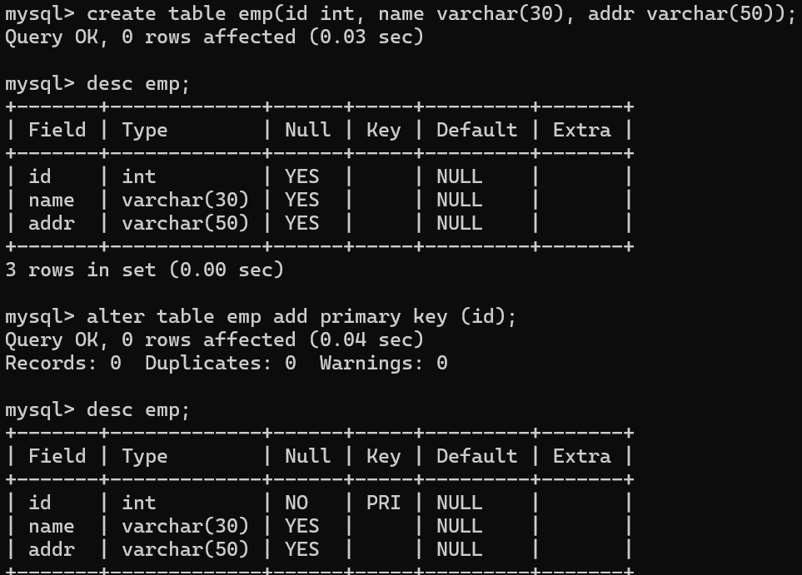
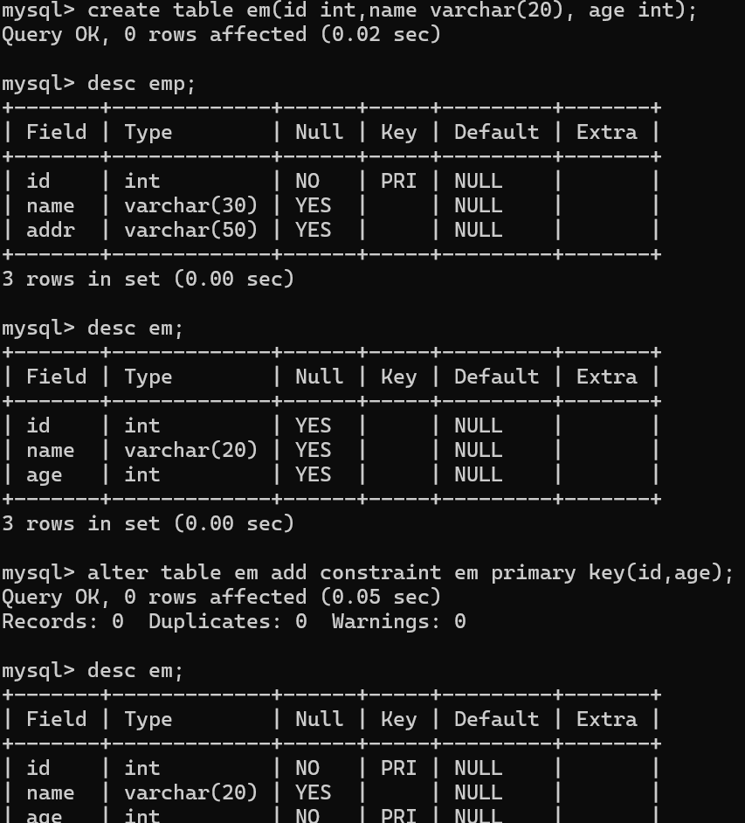
Remove primary key
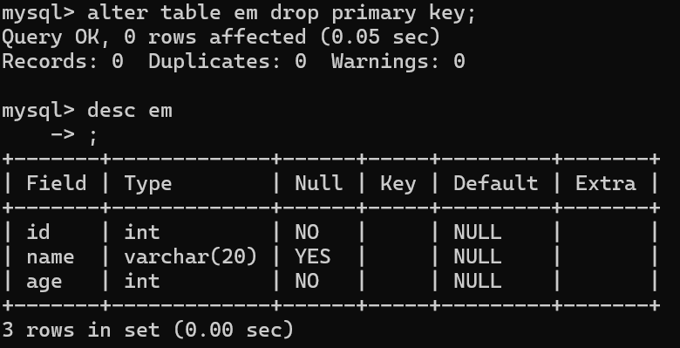

FOREIGN KEY
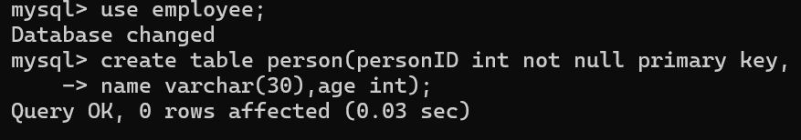
Let’s create another table for reference
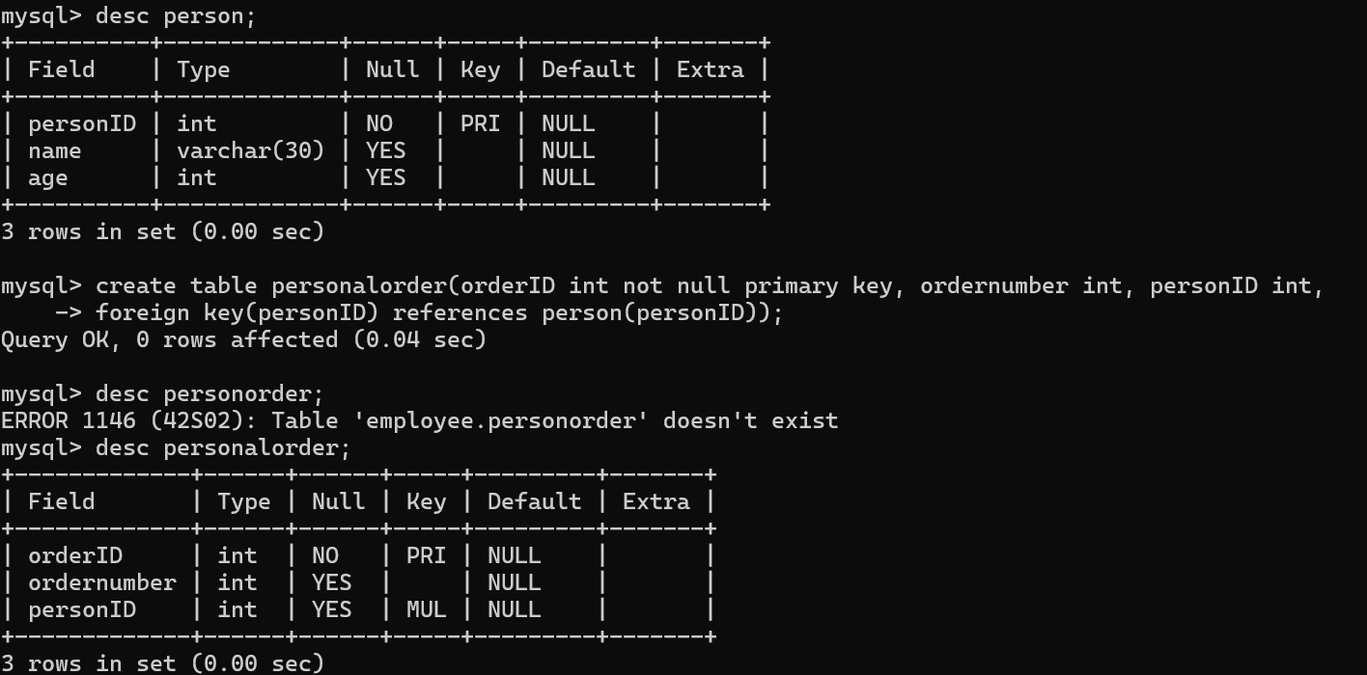
LETS CREATE FOREIGN KEY FROM EXISTING TABLE;
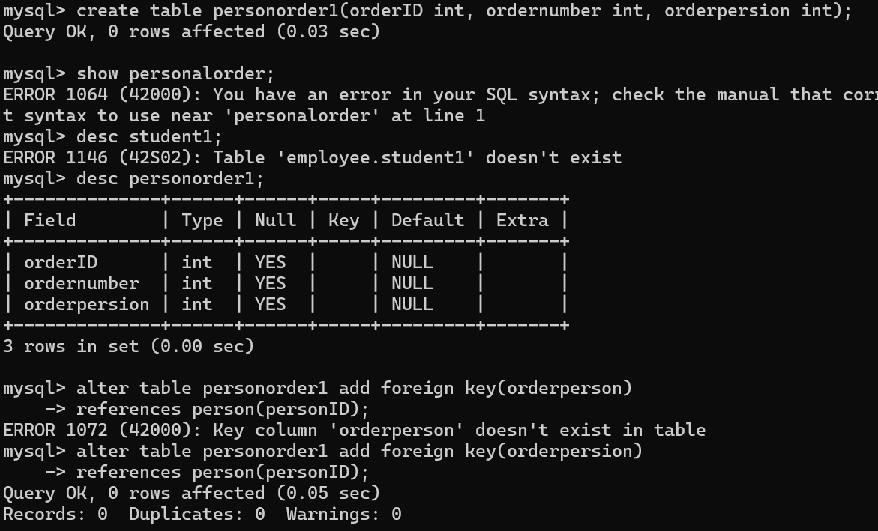
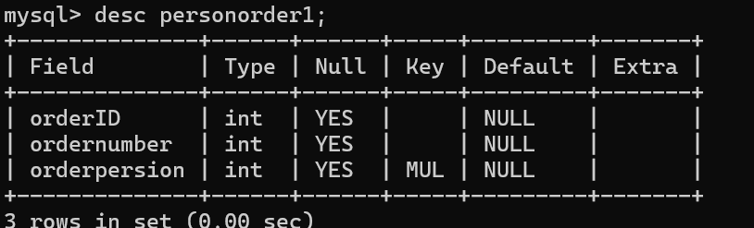
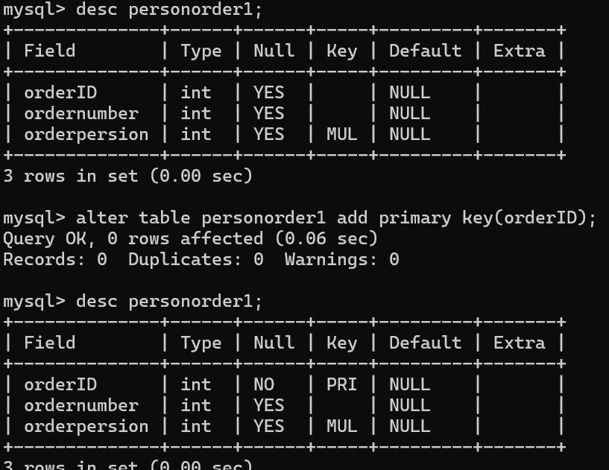
SQL JOINS – LEFT JOIN , RIGHT JOIN & CROSS JOIN
SQL join is used to combine rows from two or more table
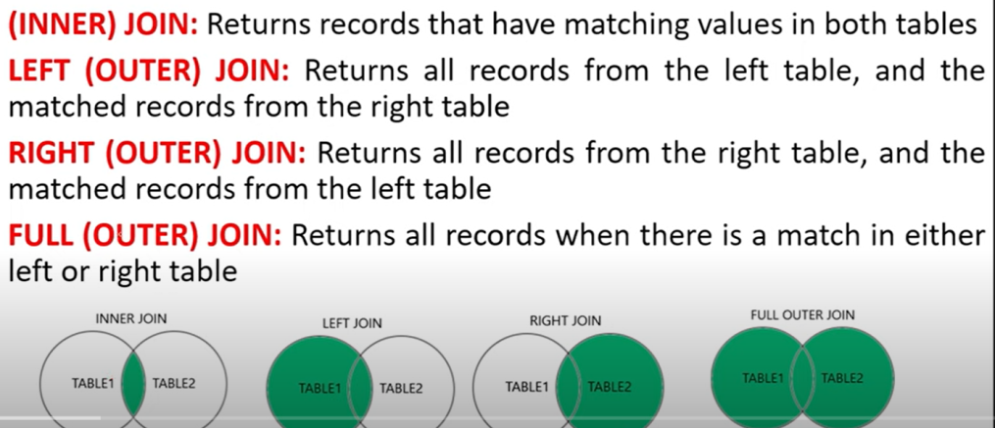
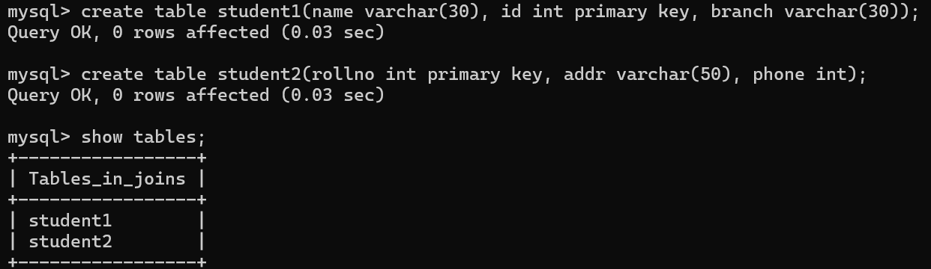
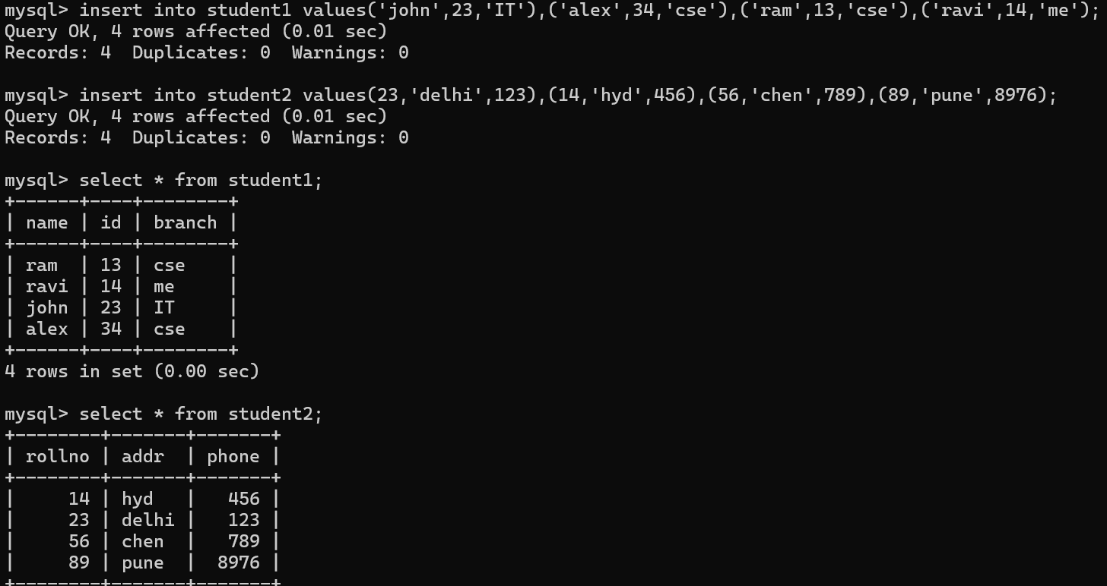

INNER JOIN
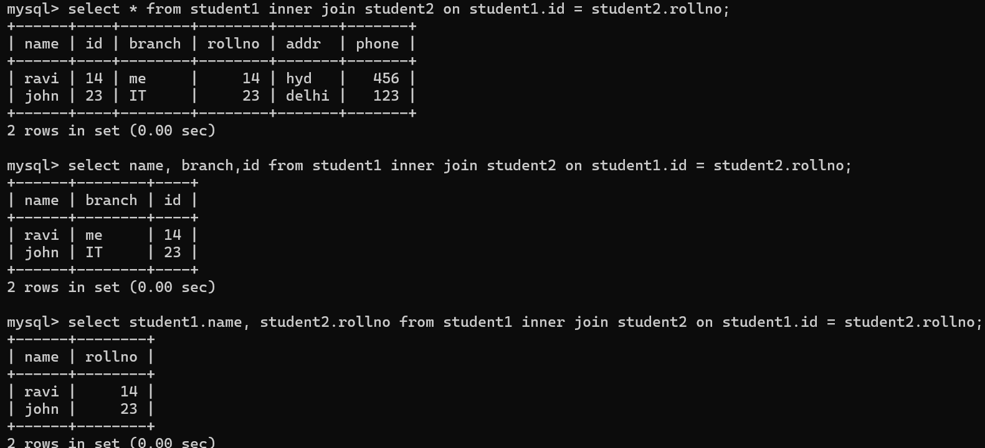
LEFT JOIN
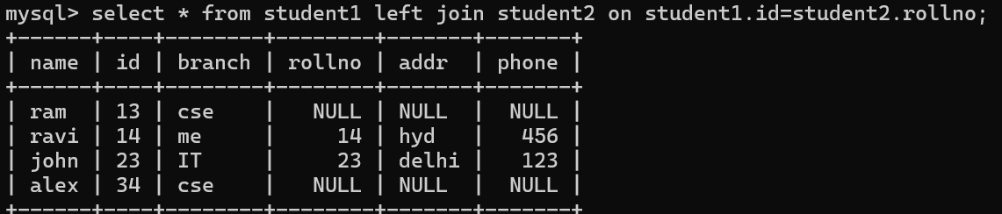
RIGHT JOIN
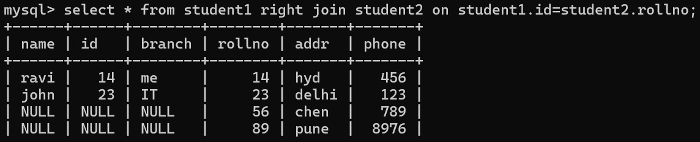
CROSS JOIN
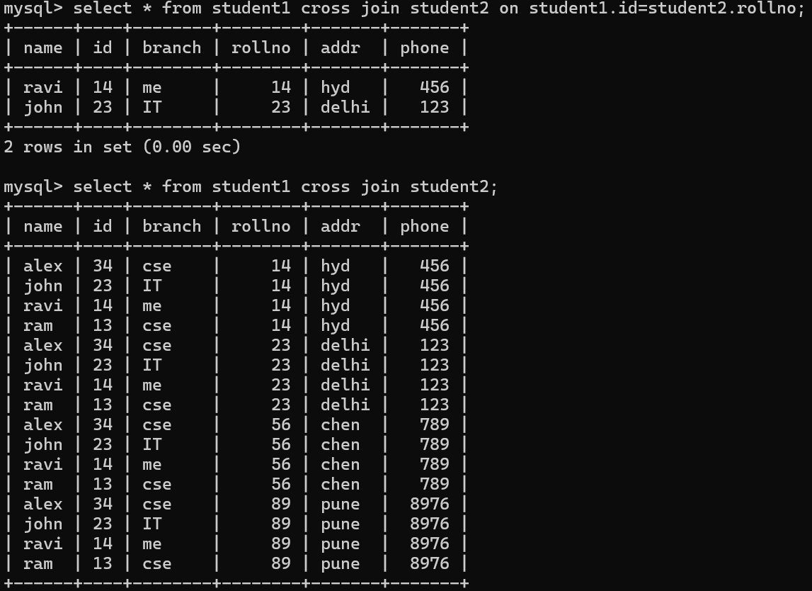

GRANT & REVOKE ( DO NOT WORK THIS)
In SQL, GRANT and REVOKE are commands used to manage permissions (or privileges) on database objects like tables, views, procedures, and more. These commands are used to give (grant) or remove (revoke) access to users or roles for performing certain actions (such as SELECT, INSERT, UPDATE, DELETE) on the database.
- GRANT: Used to give permissions to users or roles on specific database objects.
- REVOKE: Used to remove permissions that were previously granted.
These commands are essential for managing access control and security in a database system, ensuring that only authorized users can perform certain actions.
